From GCP and Jenkins to a Databricks Medallion Lakehouse

https://github.com/Divyasri6/databricks-elt-project

- Create the GCE Instance & Create Jenkins Firewall Rule: using Terraform

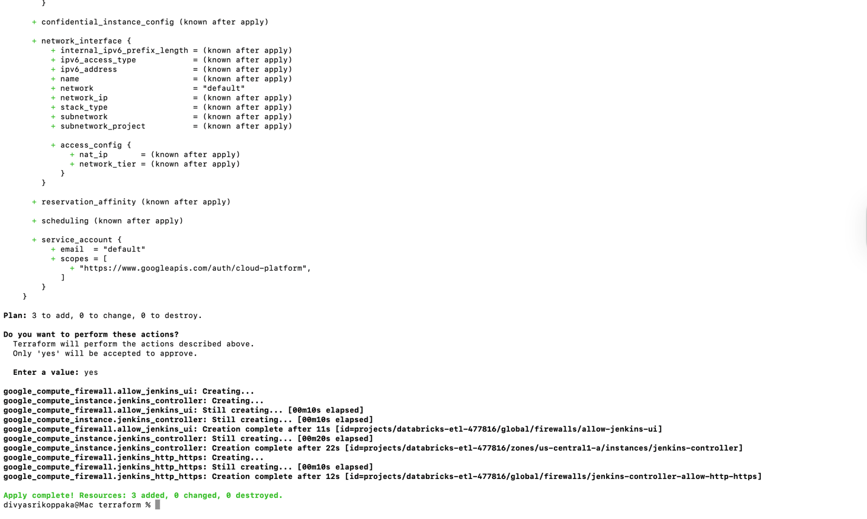
- Install Jenkins on the VM:
- Inside the VM's terminal
sudo apt-get update
sudo apt-get install -y openjdk-17-jre
sudo apt-get install -y Jenkins

- http://<EXTERNAL_IP>:8080
- http://34.46.99.31:8080/
- sudo cat /var/lib/jenkins/secrets/initialAdminPassword
to get password

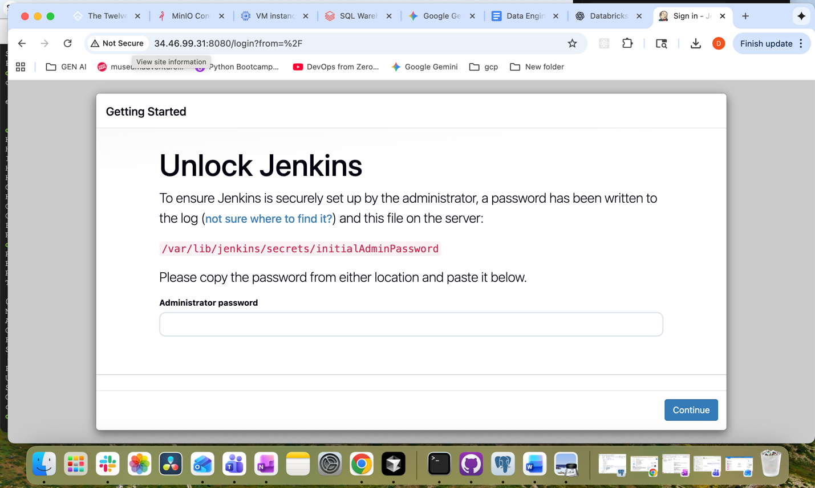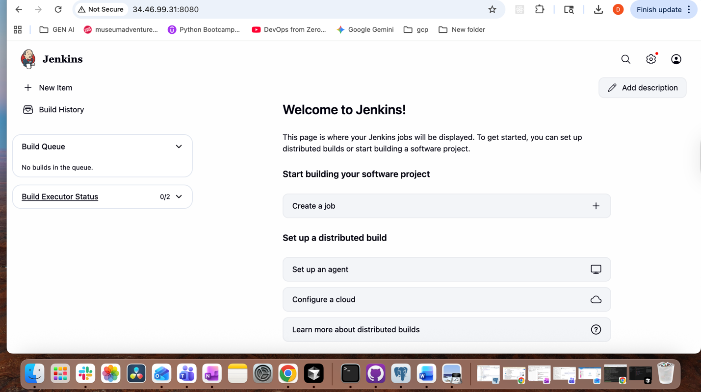
- Connecting the Clouds:
( Databricks and Google Cloud Storage (GCS))
- gcloud storage buckets create gs://databricks-demo-bucket-123 \
--project= databricks-etl-477816 \
--location=US-CENTRAL1
- gcloud storage cp users.json gs://databricks-demo-bucket-123/raw/users.json
- gcloud storage cp events.json gs://databricks-demo-bucket-123/raw/events.json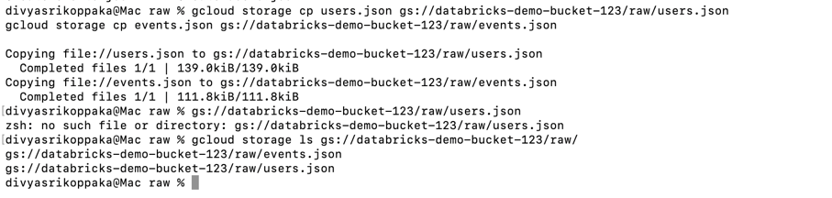
Concept | Object | Description
Key | GCP Service Account | Authenticates access to your GCS bucket.
Keyring | Databricks Storage Credential | Stores and manages the key within Databricks.
Door | Databricks External Location | Provides access to data stored in GCS.
- Establish the Secure Connection (GCP & Databricks)

- databricks-gcs-accessor@databricks-etl-477816.iam.gserviceaccount.com
- Create the GCP Service Account (The "Key")
- Grant the Service Account Bucket-Level Permissions
- Create the Databricks Storage Credential (The "Keyring")
db-uc-credential-06d6ueln58-si@uc-useast1.iam.gserviceaccount.com

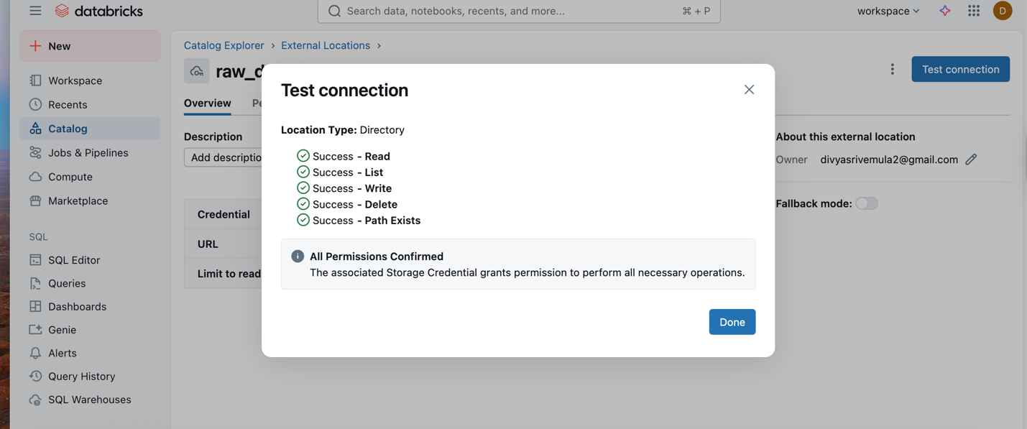
- Medallion ELT Pipeline:

Bronze Layer (Raw):
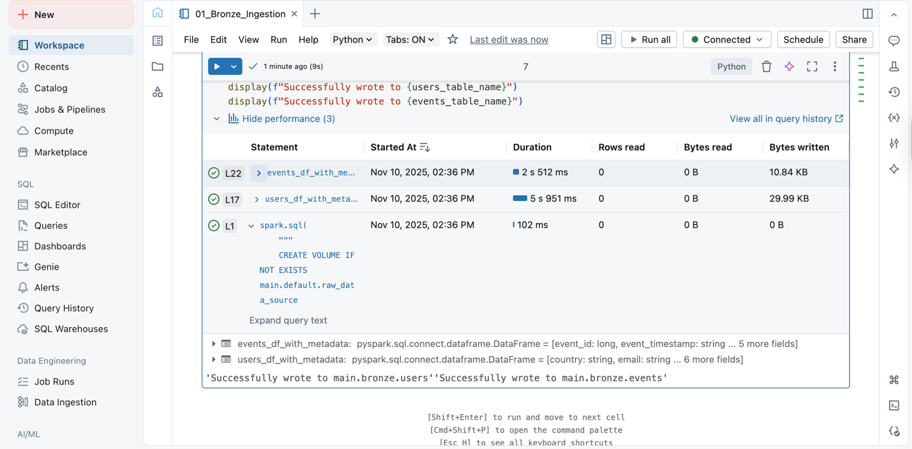
Silver Notebook: Read from the Bronze tables, clean and conform the data, join them, and write to a Silver Delta table.

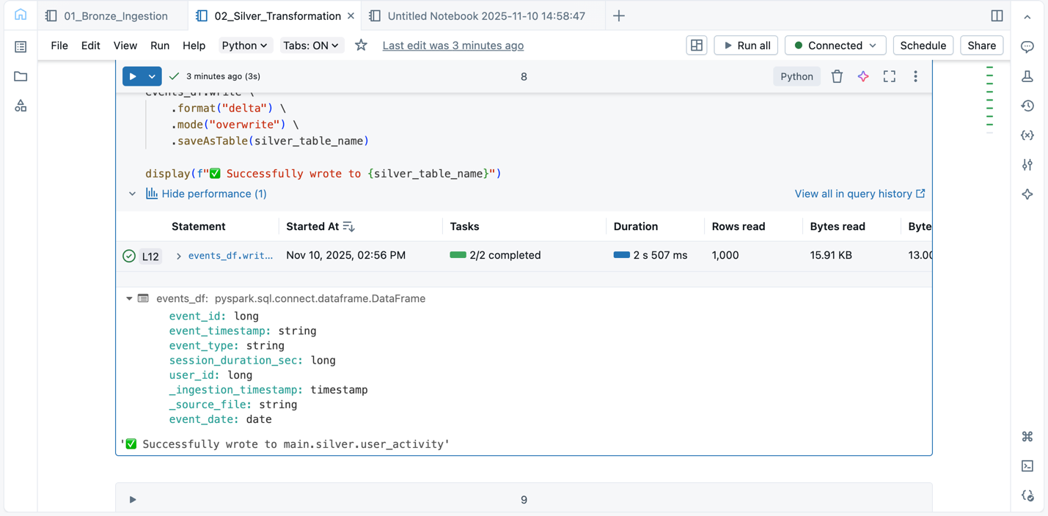
Gold Notebook: Read from the conformed Silver table and create business-level aggregates for analytics.³¹
